FRIENDS SOUTHERN SUMMER EVENTS
SENIOR CONFERENCE
VOLUNTEER STAFF INFO PACK & APPLICATION FORM

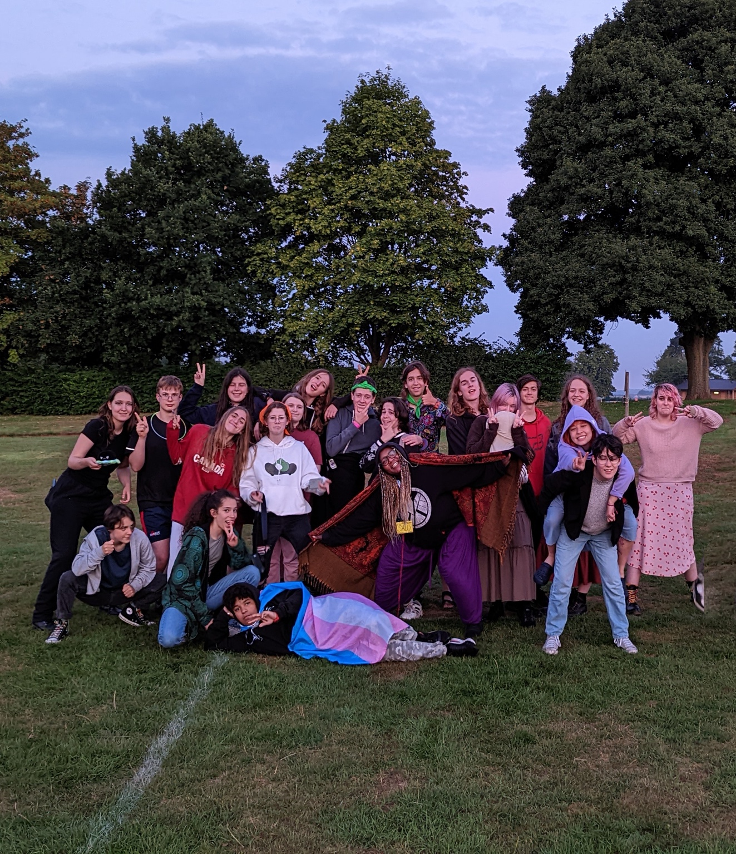

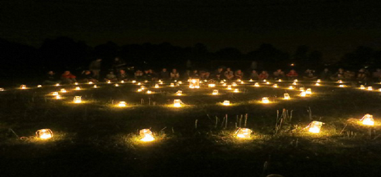

Dear Friend,
Thank you for your interest in joining the Senior Conference staff team!

In this document you will find:
- Everything you need to know about the event.
- Information about the staff team selection process.
- An initial application form - it would be helpful if you could complete and return this to us, regardless of whether you are able to volunteer this year or in future years.
- Volunteer guidelines - we ask all volunteers to agree to these before the event.
If you have any questions or queries, please do not hesitate to contact either of us. We look forward to hearing from you!

In Friendship,
Gina Bailey and Al Page
Event Coordinators

WHAT IS SENIOR CONFERENCE?

Senior Conference is a busy and intensive week in late August for around 80 young Quakers aged 15-18. Our objective is to build a worshipful Quaker community, which provides a safe space in which young people can grow and learn more about themselves and the Quaker way of being.

We come together for a week of fun, community, worship, and shared explorations of issues and subjects connected to Quakerism. Each year we explore the theme through sessions with visiting speakers, discussion in Base Groups, worship and other activities. There are also a variety of creative and active workshops, swimming, a day trip to Oxford, and lively evening entertainments.

Senior Conference is also a follow on event from Junior Gathering (for 11-14 year olds) which is similar in format, although organised largely by adults. Both events are overseen by FSSE (Friend's Summer Southern Events). Although the catchment area for conferees is predominantly the South of England, we have accepted applications from young people who live elsewhere within the UK or overseas.

FSSE is committed to providing a safe and fun place for young people to explore Quakerism and their spirituality. Two adult coordinators are responsible for the daily safe running of Senior Conference, although the Conference itself is planned by a committee of young people appointed at last year’s Conference. They are assisted by a team of adult volunteers all aged 22 or older, who support the young people in the running of their event.

Around ten of the more experienced young people take the roles of Clerks, Elders, Universal Friends, Entertainments and Base Group Facilitators Coordinators (BGFC) to organise and run the event. Each year, the newly nominated committee meets the previous year’s committee, the two event coordinators and others in the 22+ support team for a handover meeting to agree the theme. Two subsequent planning meetings are held to plan the event.

Friends Southern Summer Events follows guidelines from Britain Yearly Meeting concerning the safety and well-being of those taking part. All adult volunteers are required to have current, enhanced disclosures from the Disclosure and Barring Service (formerly Criminal Records Bureau).

Read more about how we aim to keep young people safe. Our child protection policy can be downloaded from our Policies page. https://fsse.org.uk/fsse/policies/

FSSE: Senior Conference INFORMATION 2024

Two adult coordinators are responsible for the running of Senior Conference. They are assisted by a team of adult volunteers.

Event Coordinators  Bookings Secretary  Venue | Gina Bailey and Al Page  georginabailey25@hotmail.co.uk  alexanderpage98@gmail.com  Rob Johnson  seniorconference@fsse.org.uk  Leighton Park School  Shinfield Rd, Berkshire,  Reading  RG2 7DE
Participant places  Theme | Approx. 60  How, as young Quakers, can we use our beliefs to construct a hopeful future?
Ages | 15 to 18 years old  (must be 15/under 18 by 1st September)
Meals | The week will largely be catered for vegetarians, although there will be some meat options available. Other dietary needs are also catered for (please indicate any dietary requirements on your application form).
Expenses | Staff volunteers will be reimbursed for travel expenses and pre-agreed costs relating to activities.
THE VOLUNTEER RECRUITMENT PROCESS

To apply for a place on the staff team at Senior Conference please fill in the attached application form.

- Send your completed form by email to the coordinators,
- Ideally please apply before 19th February.
- To volunteer on the staff team, you will need to be available to attend the planning meetings in February and June (dates TBC). You may be able to attend via Zoom if you are not available in person.
- You will have an informal interview with the two Event Coordinators so that they can get a sense of your motivations and what you would like to bring to the Senior Conference staff team.
- Following the meeting and your interview the Event Coordinators will select the staff team based on the following factors:
- Getting the correct gender ratio of staff to young people
- A balance of skills and experience in the team
- Suitability to the role as demonstrated in the informal interview.

Please note: We very often have more volunteers apply than there are places on the team. If we are unable to offer you a place this year because we already have a volunteer team who fit the gender/experience/skills ratio we will ask whether you would consider being on our waiting list to be called upon if young people numbers increase. If you are not asked this year, we very much encourage you to apply again in the future.

WHAT HAPPENS NEXT

- All staff roles are subject to DBS approval, the cost of which is covered by FSSE. We will be in touch with you to organise this but ask that you are prompt with assisting us in the process as your place on the staff team is only secured when you are DBS verified.
- At the June planning meeting all staff will be thoroughly briefed on the plans for the week and new staff inducted into the staff team.
- At the same time the Volunteer Guidelines form will be sent to everyone who is offered a place. Please note that staff are required to sign these and bring them to the event.

Volunteer staff application form for Senior Conference
Please complete this form if you would like to be considered as a staff volunteer for Senior Conference

PERSONAL INFORMATION

Name
Date of Birth
Address
Postcode
Email
Phone
Local Meeting
Area Meeting

If you do not have contact with a Quaker meeting what is your involvement/contact with Quakers?

Please tell us about your experience working with young people:

Please tell us about your work, study and/or interests:

Please tell us why you are interested in volunteering at Senior Conference:

Every day we offer activity sessions to the young people drawing on the skills and interests of the staff team. Are there any activities that you feel you could offer (you would be supported by other staff members)?

Do you have a First Aid qualification?
(please mark as applicable; if YES, state qualification and expiry date)

YES

NO

Details:

Any other relevant qualifications?

Please disclose any relevant health or personal issues that you feel may affect you during the event (e.g. physical health/mental health/neurodiversity/bereavement). All information is completely confidential and will not affect your application, but it will help us to provide you with the right support.

Which year(s) are you interested in volunteer?

Are you likely to have a child/sibling/relative attending Senior Conference?

YES

NO

Please add any further information you would like to give:

CoNFidENTIAL

This form must be completed by any person volunteering to be a member of staff. Details are kept by the event coordinators and will remain confidential amongst the members of the FSSE management committee. Procedures for appointing volunteers are intended to ensure that all who work with children and young people will contribute to their safety, spiritual development, and overall wellbeing.

REFERENCES

Please give details of two people who are not related to you to whom reference can be made.

- Both should know you well.
- At least one should have known you for at least two years.
- At least one should be able to comment on your experience of, attitudes towards, and behaviour with children/young people.
- One should be a Quaker.
- One should know you from some other area of life (for example, as neighbour, employer, work colleague).
- They should not be a member of your family.

Reference 1 |  | Reference 2
Name |  | Name
Address |  | Address
Postcode |  | Postcode
Email Address |  | Email Address
Telephone |  | Telephone
Connection with you* |  | Connection with you*

*(e.g. Quaker, work colleague, neighbour)

DECLARATION

I understand that I am legally required to declare any convictions for sexual offences, or for offences against children/young people and that if I have been convicted of any such offences I cannot volunteer to work with children/young people. I also declare here any other convictions. I have never been convicted of a sexual offence, or an offence against children.

I give permission for enquiries to be made about me as necessary.

NAME

DATE

SIGNATURE

VOLUNTEER GUIDELINES

FSSE Senior Conference and Senior Conference are Quaker events and so Quaker values and practices underlie the way we work together. We are committed to providing an environment in which all young people and staff are valued and respected as individuals and Quaker values are upheld in what we do, the way we act and the way we treat each other.

As a staff team we are role models to the young people and should always bear this in mind. In order to ensure a successful and safe week we ask all staff to read and sign these guidelines:

- Treat all young people with respect and dignity and be aware of your language, tone of voice and body language.

- Encourage an atmosphere of mutual trust, support, and care.

- Recognise when you are too tired or stressed to work cooperatively and inform the Event Coordinators if this situation arises or you are concerned that it may.

- Be prepared to be on time for all sessions, meetings, and jobs. Sessions are not optional unless it is your time off.

- If you are unable to do a job or are likely to be late then please arrange for someone to cover for you.

- If you need to make a change to your night duty or job allocations, please talk to the Event Coordinators.

- Equal Opportunities: Junior Gathering wishes to include everyone; no-one should feel excluded or isolated for any reason. Please consider how you can contribute to an inclusive atmosphere, taking into account people’s identities and experiences.

- It is important that you observe the health and safety rules which apply to the site, including any off-limits areas. These will be explained in detail at the opening staff meeting.

- There should be no smoking, alcohol, or illegal substances on site at any time.

- If you need to leave the site for a cigarette or to use a vape or e-cigarette , please inform the Event Coordinators.

- If you are signed off-duty in the evening you may leave the site but you may not drink alcohol or take any recreational drugs.

The Event Coordinators have overall responsibility for Senior Conference. This includes the site, young people and staff. If you have any concerns about anything during the week it is important that you discuss them with the Event Coordinators.

I have read and understand these guidelines and agree that I will abide by them during Senior Conference. In signing these guidelines, I am confirming that I have read, understood and will adhere to the FSSE Child Protection Policy.

NAME

DATE

SIGNATURE

Thank you for taking the time to complete this form.

