Senior Conference Epistle 2022
Friends,
“The poetics of the oppressed is essentially the poetics of liberation”
- Augusto Boal
Our experiences are all connected; our oppression, our pain, and our privilege are all entangled in a web of power systems and hierarchies which make up our society. In order to be liberated, these systems which oppress so many must be deconstructed. However, it is not just systems which must change: we all have a part to play in society’s evolution.
We bring you warm greetings from Sibford School, Oxfordshire, where 52 young people met between the 20th and the 27th of August to gather in fellowship and discuss our theme, “Intersectionality: Exploring Different Perspectives”. An introductory session set the tone for the week by describing the concept of intersectionality, defined as: “the interconnected nature of social categorisations such as race, class, and gender as they apply to a given individual or group, regarded as creating overlapping and interdependent systems of discrimination or disadvantage”. The session encouraged acceptance and inclusion. People were called to express themselves without fear of making mistakes, but also to accept constructive criticism and challenge from others.
“If you have come to help me then you are wasting your time, but if you have come because your liberation is bound up in mine, then let us work together”
- Aboriginal rights activist group (Unattributed)
This year’s Swarthmore Lecturer, Helen Minnis, a professor of Child and Adolescent Psychiatry, was our first speaker. She facilitated a conversation in which many of us shared our own exposure to marginalisation, silencing and stereotyping. There was a powerful feeling of vulnerability, and a sense that Conference is a community where we are able to share our pain and oppression, finding not only empathy but also solidarity. Although we greatly appreciated many participants’ willingness to share their experiences, Helen also reminded us that no-one owes anyone else their lived experience of suffering, and that the responsibility is on those in positions of privilege to combat oppression.
We also heard from two of our adult volunteers, firstly on increasing participation in Westminster and secondly on Non-Violent Communication. Our first talk focused on the accessibility of politics. We were asked to guess statistics about the representation of marginalised groups in Parliament. When we were told the real numbers, there was audible dismay at how low these figures are. We were told about the barriers presented by the fabric of the Palace of Westminster itself and the resistance at the highest levels of our political system to addressing this. Despite the disheartening revelations about the centre of our democracy, we left determined to change things for the better, with the encouragement that we become more involved in politics.
The second talk in this session was about Non-Violent Communication, a technique pioneered by Marshall Rosenberg. It challenged us with the revelation that our everyday speech can often be unintentionally violent. The Rosenberg system aims to counter this, acknowledging each other's differing needs and experiences in order to come to a mutually enriching outcome. We were left possessing tools which we can apply in everyday interactions, for example at work or school, allowing us to assert confidence without aggression. We are very grateful for the generous offer of both our volunteers’ time and energy. The passion with which they both spoke has increased our conviction to make positive change in our society.
Our fourth speaker of the week was Judith Moran, the director of Quaker Social Action (QSA). Judith described her organisation’s approach to equity, diversity and inclusion, but it was the stories of QSA’s work on the ground that we responded to most enthusiastically. One such project was “Down to Earth”, a scheme to help those experiencing funeral poverty which elicited cross-party support in Parliament. The work they do in the poverty space is a glowing example of Quaker values in action. QSA can not, Judith said, solve every problem, and so the projects they run are intended to help a limited number of people in specific and practical ways. Its contribution to the battle against economic oppression is small in stature but huge in impact for those it works with. There was also an emphasis on treating those whom the charity seeks to support with respect, as opposed to patronising them. Like QSA, we must make every effort, however small, to fight any kind of marginalisation in our society.
We felt a strong bond across the community, not only for the conferees, but also with the adult volunteers, who presented us with an entertaining and emotive ‘Any Questions’ session. Social activities allowed us to create and strengthen these bonds as we discovered more about each other’s backgrounds and interests. Most importantly, we will remember the love and laughter we have shared, be it during anarchic organised social activities, base groups, or in private moments, sitting together between sessions in the airy foyer or at meal-times. It was evident that the Spirit was here. It may have been defined and expressed in different ways, but undeniably something moved amongst us. Ministry from our dear Friends was frequent, deep and moving. Shared worship with Junior Gathering, our sibling event, in Oxford saw us join with Friends younger than us in a spiritually rich meeting. We thank the members of Oxford Meeting for so kindly hosting us.
This week that we spend annually in each other’s company is a constructive, joyous occasion where old friendships are rekindled and new ones sparked. Participants often observe that they can truly express themselves, a sentiment we rarely encounter in everyday life. A fellowship grounded in love and mutual acceptance is created which extends beyond the short time here at Conference. This year was no exception.
Signed in and on behalf of Senior Conference 2022,
Rozzie W and Edward R
Clerks 2022

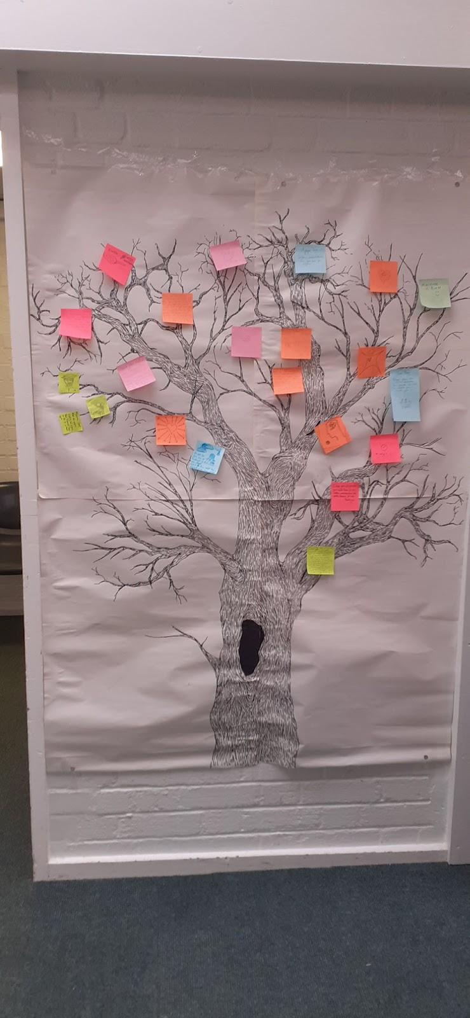
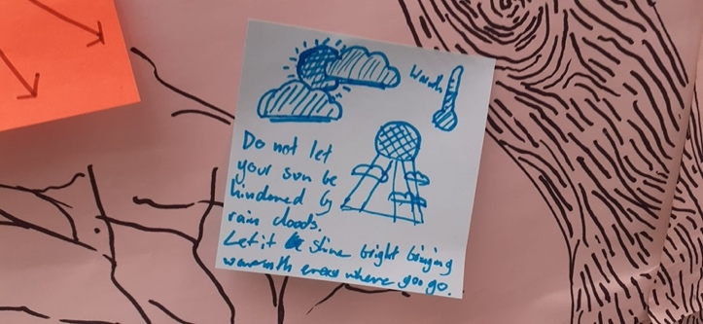

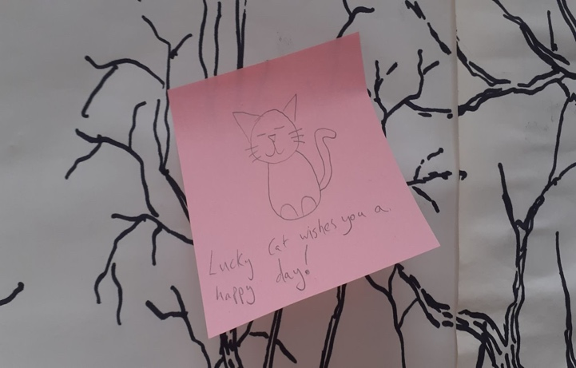

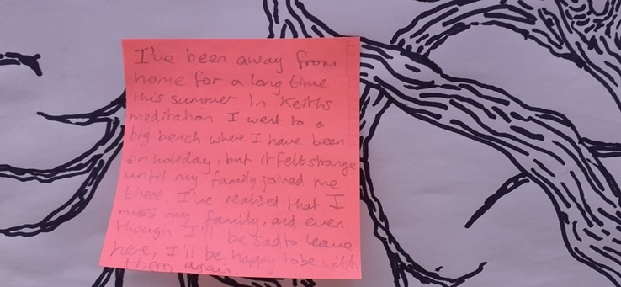

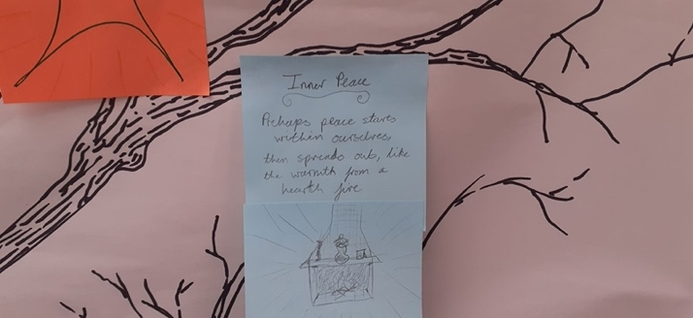

We attach these images of the "Minis-tree", a large sheet beautifully drawn by one of our elders. Participants were invited to share ministry outside of epilogue by placing sticky notes on the tree.
(Image descriptions – a black and white drawing of a tree with coloured post-it notes on it, four close up images of coloured post it notes on a the tree drawing)

